SENSORS TESTING
The system is made up of several low-cost sensors sourced from the open market to measure key weather parameters. Except for the rainfall sensor—which is assembled from discrete electronic components (resistor, capacitor, and Hall-effect switch)—the sensors are purchased already calibrated from the factory."
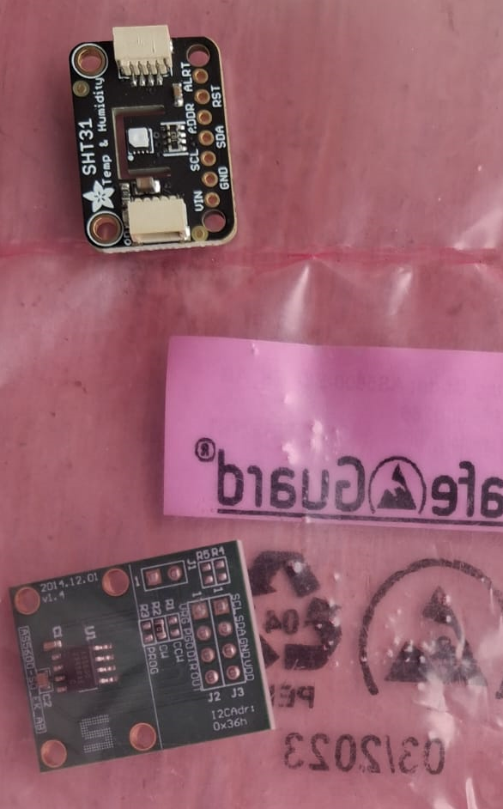
Figure 1Sensors on arrival

The sensor housing and the wiring is done at the KMD workshop by the KMD technicians
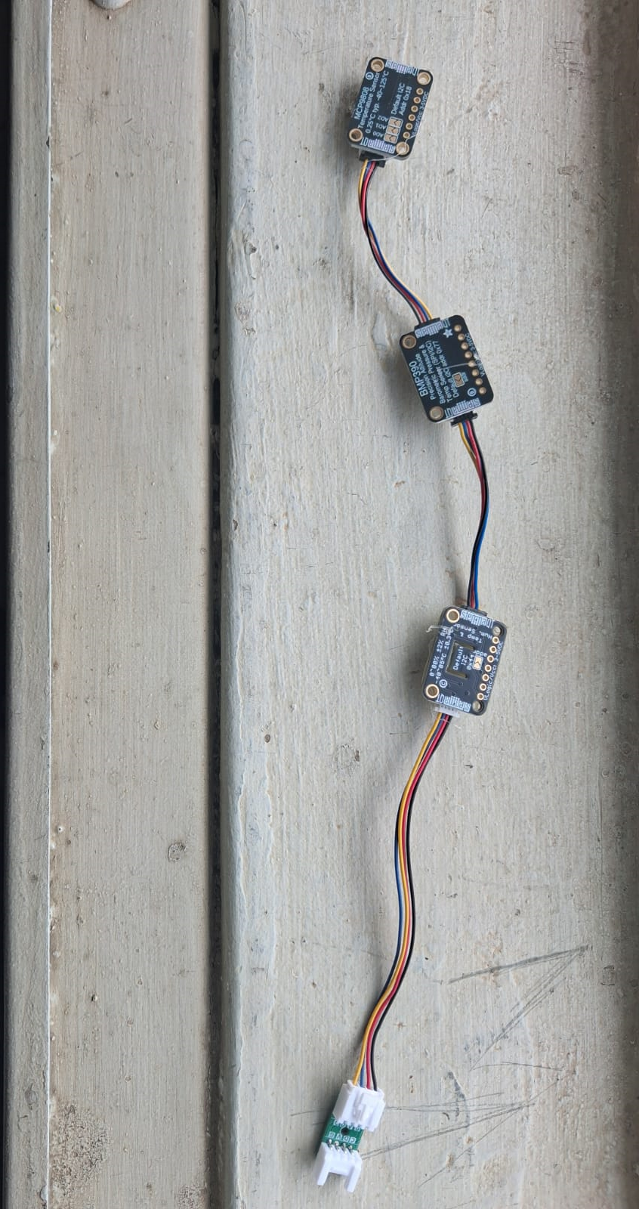
Figure 2 Assembled pressure, Humidity and Temperature sensors ready for testing

The Sensors are the taken through quality testing procedure as indicated here below.
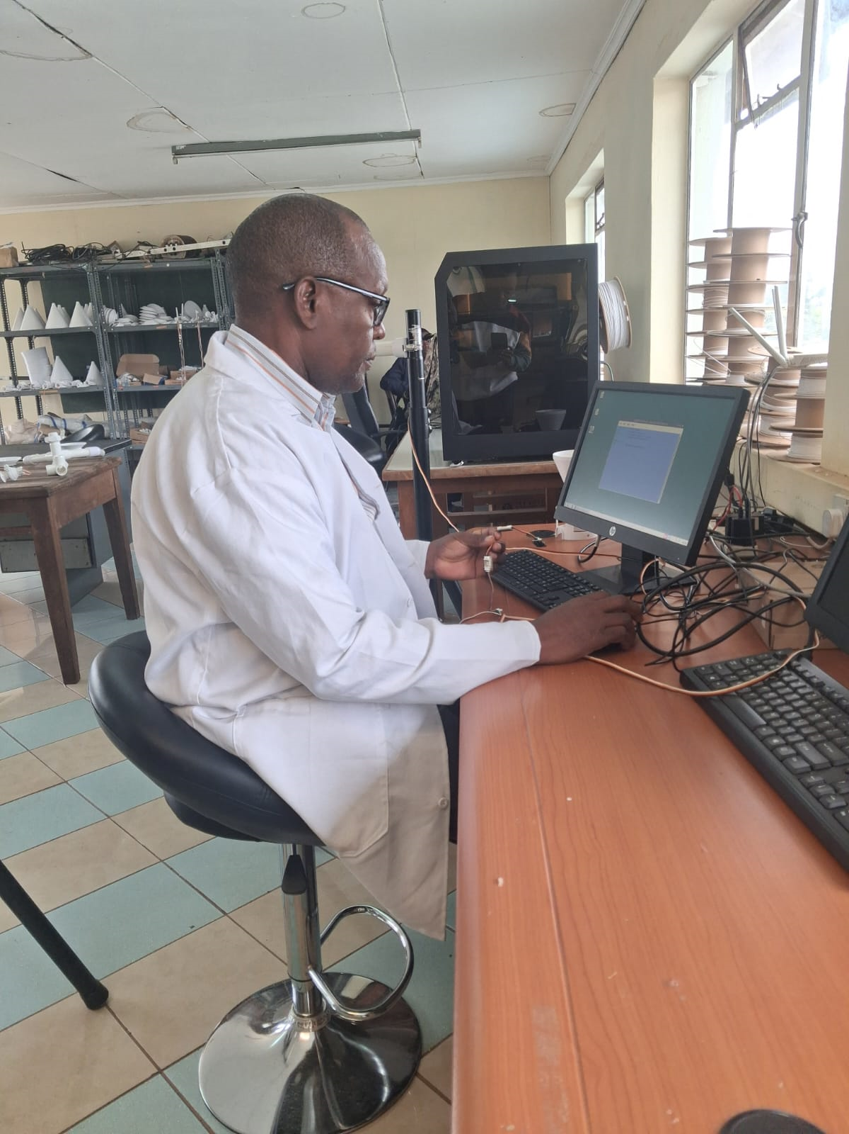
Figure 3 Sensor being tested

The sensors are tested for any fault that could have originated from factory, or during wiring. Raspberry Pi computer with python script is use during this testing process
After testing, the sensors are placed in their respective housing ready for the station assembly
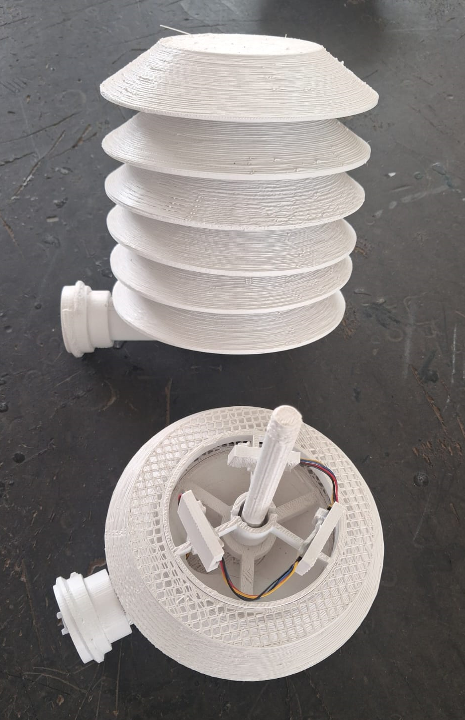
Figure 4Pressure, Humidity and Temperature sensors assembly ready for station assembly

Rain gauge Sensor Testing and Calibration

Stage 1: The rain gauge sensor is assembled from discrete electronics components (Hall effect sensor, resistor and a capacitor).
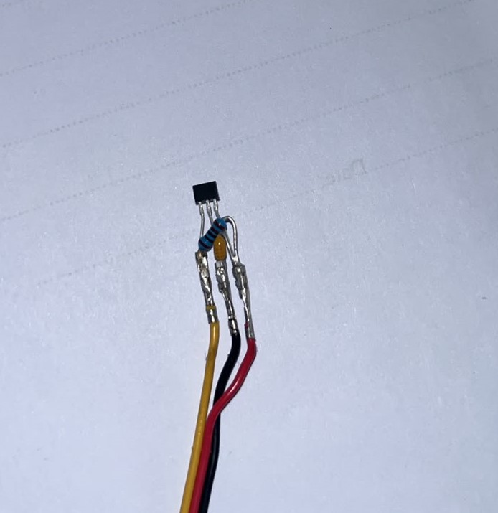

Stage 2: Balancing of the tipping buckets.
The gauge features a WMO-recommended resolution of 0.2 mm with a catchment diameter of approximately 200 mm. The volume for one bucket tip is therefore approximately 6,283 mm³ (6.3 mL). Both buckets are adjusted to tip at this precise volume by using a pipette to fill them, while ensuring the entire unit remains leveled with a spirit level
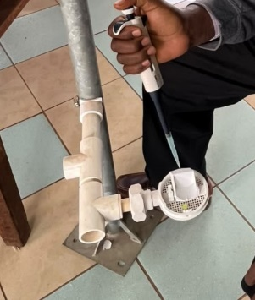

Stage 3: Collecting data for determining the weight of a single tip
A tank is filled with approximately 0.5 kg of water, and its initial weight is recorded. The water is then allowed to drip through the tipping bucket, and the final weight of the tank is recorded. Throughout this process, a Raspberry Pi connected to the bucket's Hall effect switch records each tip. The total number of tips generated by the water volume is documented. This entire procedure repeated five times
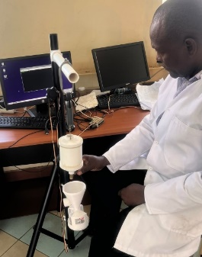
stage 4. Determining the average weight of a tip
Using the data collected in stage 3 above, the average weight of one tip is established.

Stage 5. Determining the diameter of the rain gauge catchment area
Knowing the density of water (1g/cm³) and the resolution of the rain gauge(0.2mm) you can calculate the area of the rain gauge and therefore the diameter of the rain gauge.
Example:
g/tip=5.789g
Vol/tip=5789mm³
tips at 0.2mm
Area/tip=28,945mm²
Radius of the area=95.9868mm, Diameter =191.9736mm
Stage 6: Fabricating the rain gauge catchment part.
Insert the radius or diameter into the computer's 3D model, then fabricate the rain gauge catchment part. Assign an identical number to both the bucket and the rain gauge part. Finally, save the 3D model in the database for future field replacements
Note: The fabricated rain gauge is only compatible with that specific tipping bucket as fur as calibration is concerned.

